Mind Mirror: An AI-Powered Emotion-Aware Journaling Application
Seidenberg School of Computer Science and Information Systems, Pace University
15 Beekman St, New York, NY, USA

Chintan Kotadiya
ck04429n@pace.edu
Sanket Matroja
sm05734n@pace.edu
Krishna Pothana
kp94359n@pace.edu
Vanessa Agbugba
va82643n@pace.edu
Rafaela Hollanda
rp01885n@pace.edu

Abstract— This paper presents Mind Mirror, an AI-powered journaling system designed to enhance emotional awareness through sentiment analysis, mood prediction, and visual trend tracking. Traditional journaling tools support self-expression but lack structured emotional analytics and integration with guided therapeutic workflows. Mind Mirror addresses this limitation by enabling users to record journal entries, receive automated sentiment classification, and visualize mood patterns over time through an interactive dashboard. The system further supports optional therapist collaboration by allowing selective sharing of entries. The platform is implemented using the FARM stack, consisting of a React frontend, a FastAPI-based Python backend, and MongoDB for data persistence, with a fine-tuned DistilBERT model used for mood prediction. System validation was conducted using synthetic and sample data, demonstrating successful functionality across all core features. The results demonstrate the feasibility of integrating AI-driven analysis with reflective journaling to support mental well-being.
Keywords—artificial intelligence, sentiment analysis, journaling systems, digital mental health, natural language processing

Introduction
Emotional awareness is a central component of mental well-being, yet many individuals struggle to identify, interpret, and respond to their emotional states in a consistent manner. Traditional journaling provides a valuable outlet for self-expression, but it is typically unstructured and offers limited support for recognizing emotional patterns over time. As a result, many users record reflections without receiving meaningful analytical feedback or understanding how their emotional states evolve across days and weeks.
Recent advances in artificial intelligence, particularly in natural language processing (NLP), create opportunities to strengthen journaling tools through automated analysis of textual reflections. Sentiment analysis models can classify emotional tone, while dashboard-based visualizations can reveal longitudinal patterns that are difficult to notice in isolated entries. Prior work on expressive writing suggests that writing about personal experiences can contribute to improved emotional processing and health outcomes [3], [5]. In parallel, research on digital mental health applications suggests that accessible software tools can broaden support and increase user engagement when they are structured and easy to use [4].
This study introduces Mind Mirror, a web-based emotion-aware journaling application designed to connect reflective writing with AI-generated emotional insight. The platform enables users to submit journal entries, receive sentiment and mood-related feedback, and review their emotional history through visual dashboards. In its broader design, the platform also supports selective sharing of entries with therapists so that clinicians can review user-authorized content within a secure workflow.
The study addresses three research questions: How can sentiment analysis be integrated into a journaling system to enhance emotional awareness? How can trend visualization support pattern recognition and sustained reflection? How can a journaling platform support future therapist collaboration while preserving user control over shared content? Mind Mirror is intended to demonstrate that AI-assisted journaling can move beyond passive storage and toward structured, actionable self-reflection.

Literature Review

Expressive Writing and Emotional Health
Expressive writing has been widely studied as a means of improving emotional processing and psychological well-being. Pennebaker and Chung describe expressive writing as a structured activity through which individuals write about difficult experiences, often producing measurable benefits in health and well-being [3]. Smyth likewise reports that written emotional expression is associated with improved outcomes across multiple health-related dimensions, including psychological well-being and general functioning [5]. These findings establish a strong theoretical basis for systems that encourage reflective writing as part of mental wellness support.

Digital Mental Health Applications
Digital mental health platforms have expanded access to self-monitoring, reflection, and treatment-oriented support. A systematic review by Miralles et al. found growing interest in mobile applications for mental disorders, particularly for anxiety- and depression-related use cases, while also emphasizing the importance of sound technical and psychological design [4]. These findings support the usefulness of journaling systems that combine accessibility with guided structure instead of acting as plain text repositories.

Sentiment Analysis and Emotion Detection
Sentiment analysis methods provide a practical foundation for extracting emotional signals from user-written reflections. Hutto and Gilbert introduced VADER as an efficient, rule-based model for sentiment analysis of social media text and demonstrated that lightweight sentiment models can perform well on short, user-generated content [1]. Although journaling entries may be more nuanced than short social posts, the same principle applies: NLP can convert free-form text into structured emotional signals that support visualization and feedback.

Therapist-Supported Digital Systems
Digital self-monitoring systems can be strengthened when they support a path toward clinician involvement. de Zwaan et al. examined a web-based self-help and feedback intervention and found that automated monitoring systems can deliver meaningful support, while therapist involvement can improve user satisfaction even when the automated core remains central [2]. This supports Mind Mirror's long-term design goal of allowing users to selectively share entries with therapists for more contextual and personalized discussion.

Methodoly
Before you begin to format your paper, first write and save the content as a separate text file. Complete all content and organizational editing before formatting. Please note sections A-D below for more information on proofreading, spelling and grammar.
Keep your text and graphic files separate until after the text has been formatted and styled. Do not use hard tabs, and limit use of hard returns to only one return at the end of a paragraph. Do not add any kind of pagination anywhere in the paper. Do not number text heads-the template will do that for you.

Achitecture Diagram
Figure 1 illustrates the high-level architecture of Mind Mirror, which follows a client-server model implemented using the FARM stack. The frontend is developed using React and communicates with a FastAPI-based backend implemented in Python through RESTful APIs. The backend processes journal entries, interfaces with the sentiment analysis model, and manages data persistence using MongoDB. This architecture enables efficient handling of asynchronous requests and seamless integration with machine learning components. FastAPI provides high-performance API execution and native compatibility with Python-based NLP models.

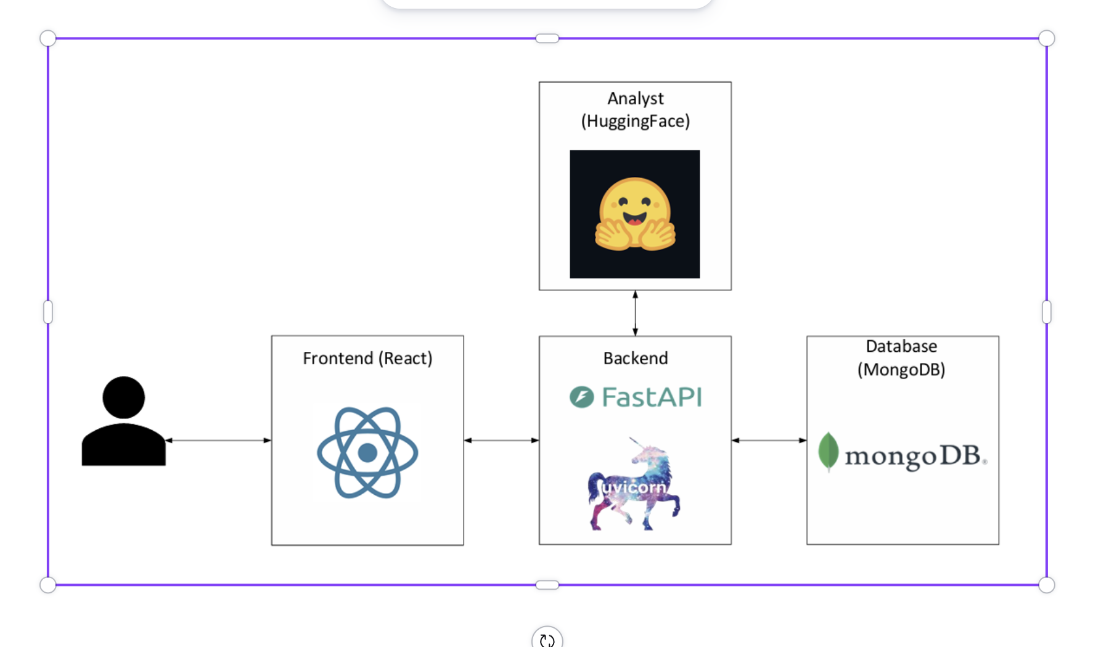
- Achitecture Diagram

ER Diagram
The data model shown in Figure 2 captures the primary entities used by the prototype. A single User can create many JournalEntry records, and each entry stores reflection text together with mood and sentiment fields. Each JournalEntry is associated with one Analysis record containing model metadata, sentiment labels, confidence information, and processed timestamps. A Suggestion record can optionally be linked to an entry to store advice text derived from analysis results. This schema supports separation between raw user reflections, model outputs, and optional feedback artifacts.

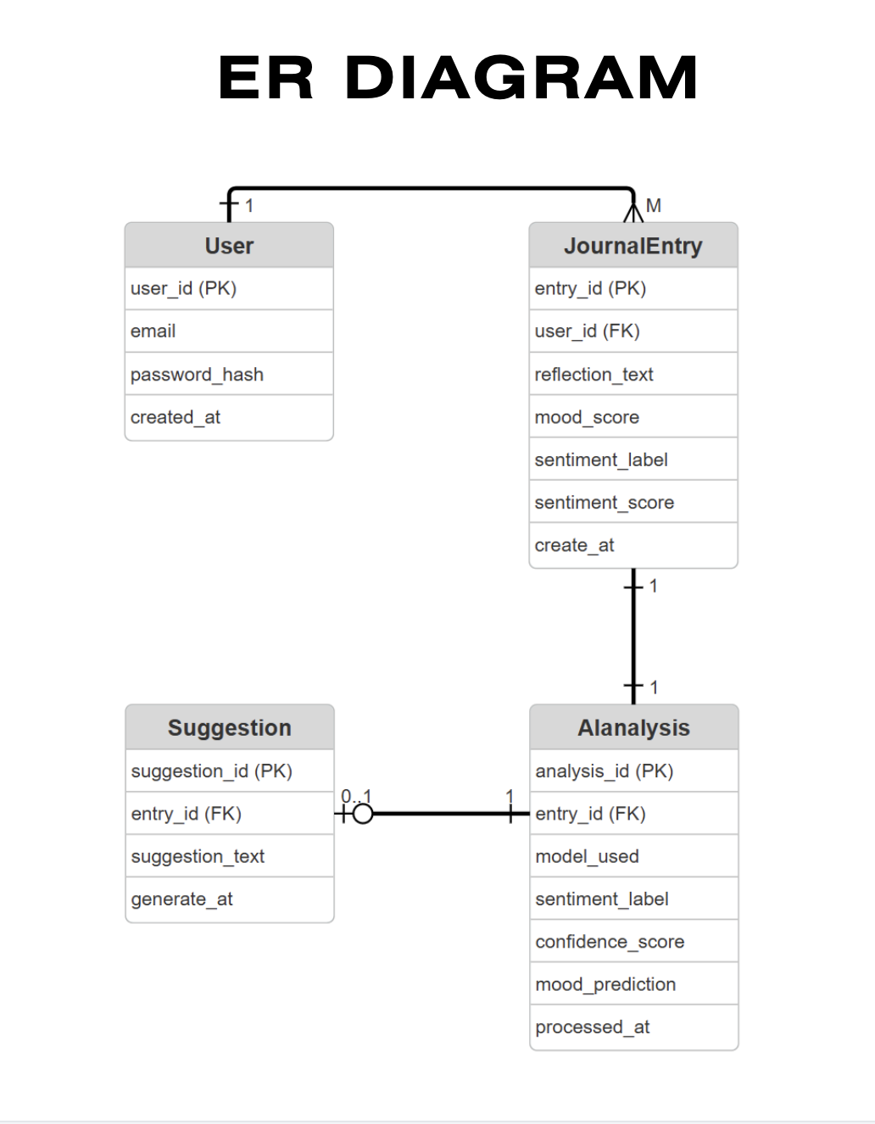
- ER Diagram

Context Diagram
Figure 3 presents the system context. The user writes a reflection through the journal input screen, submits the entry to Mind Mirror, and receives both a sentiment result and advice generated through AI-connected services. Mind Mirror stores and retrieves entries from MongoDB and sends prior records to the mood history and feedback view for longitudinal review. The context diagram makes clear that the system is not limited to one transaction; instead, it supports an ongoing cycle of entry, analysis, storage, and historical review.

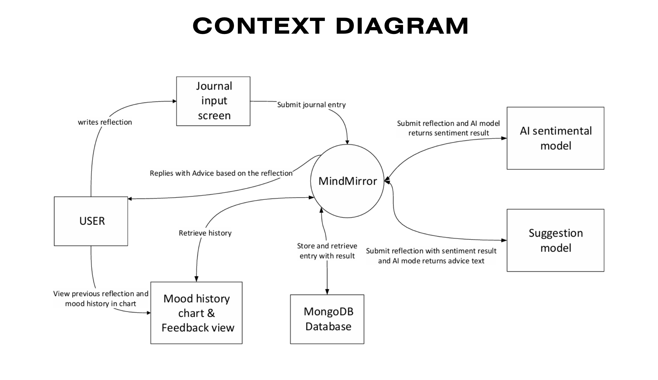
- Context Diagram

Sequence Diagram Journal Entry
The journal-entry workflow in Figure 4 begins when the user writes a reflection and submits it through the React frontend. The frontend issues a POST request to the FastAPI backend, which validates the payload and forwards the reflection text to the sentiment and emotion model. The model returns structured outputs such as sentiment label, confidence score, emotion label, and mood score. The FastAPI backend then stores both the original entry and the analysis result in MongoDB before returning the processed data to the frontend for display. This sequence supports immediate feedback while preserving a durable analysis history.

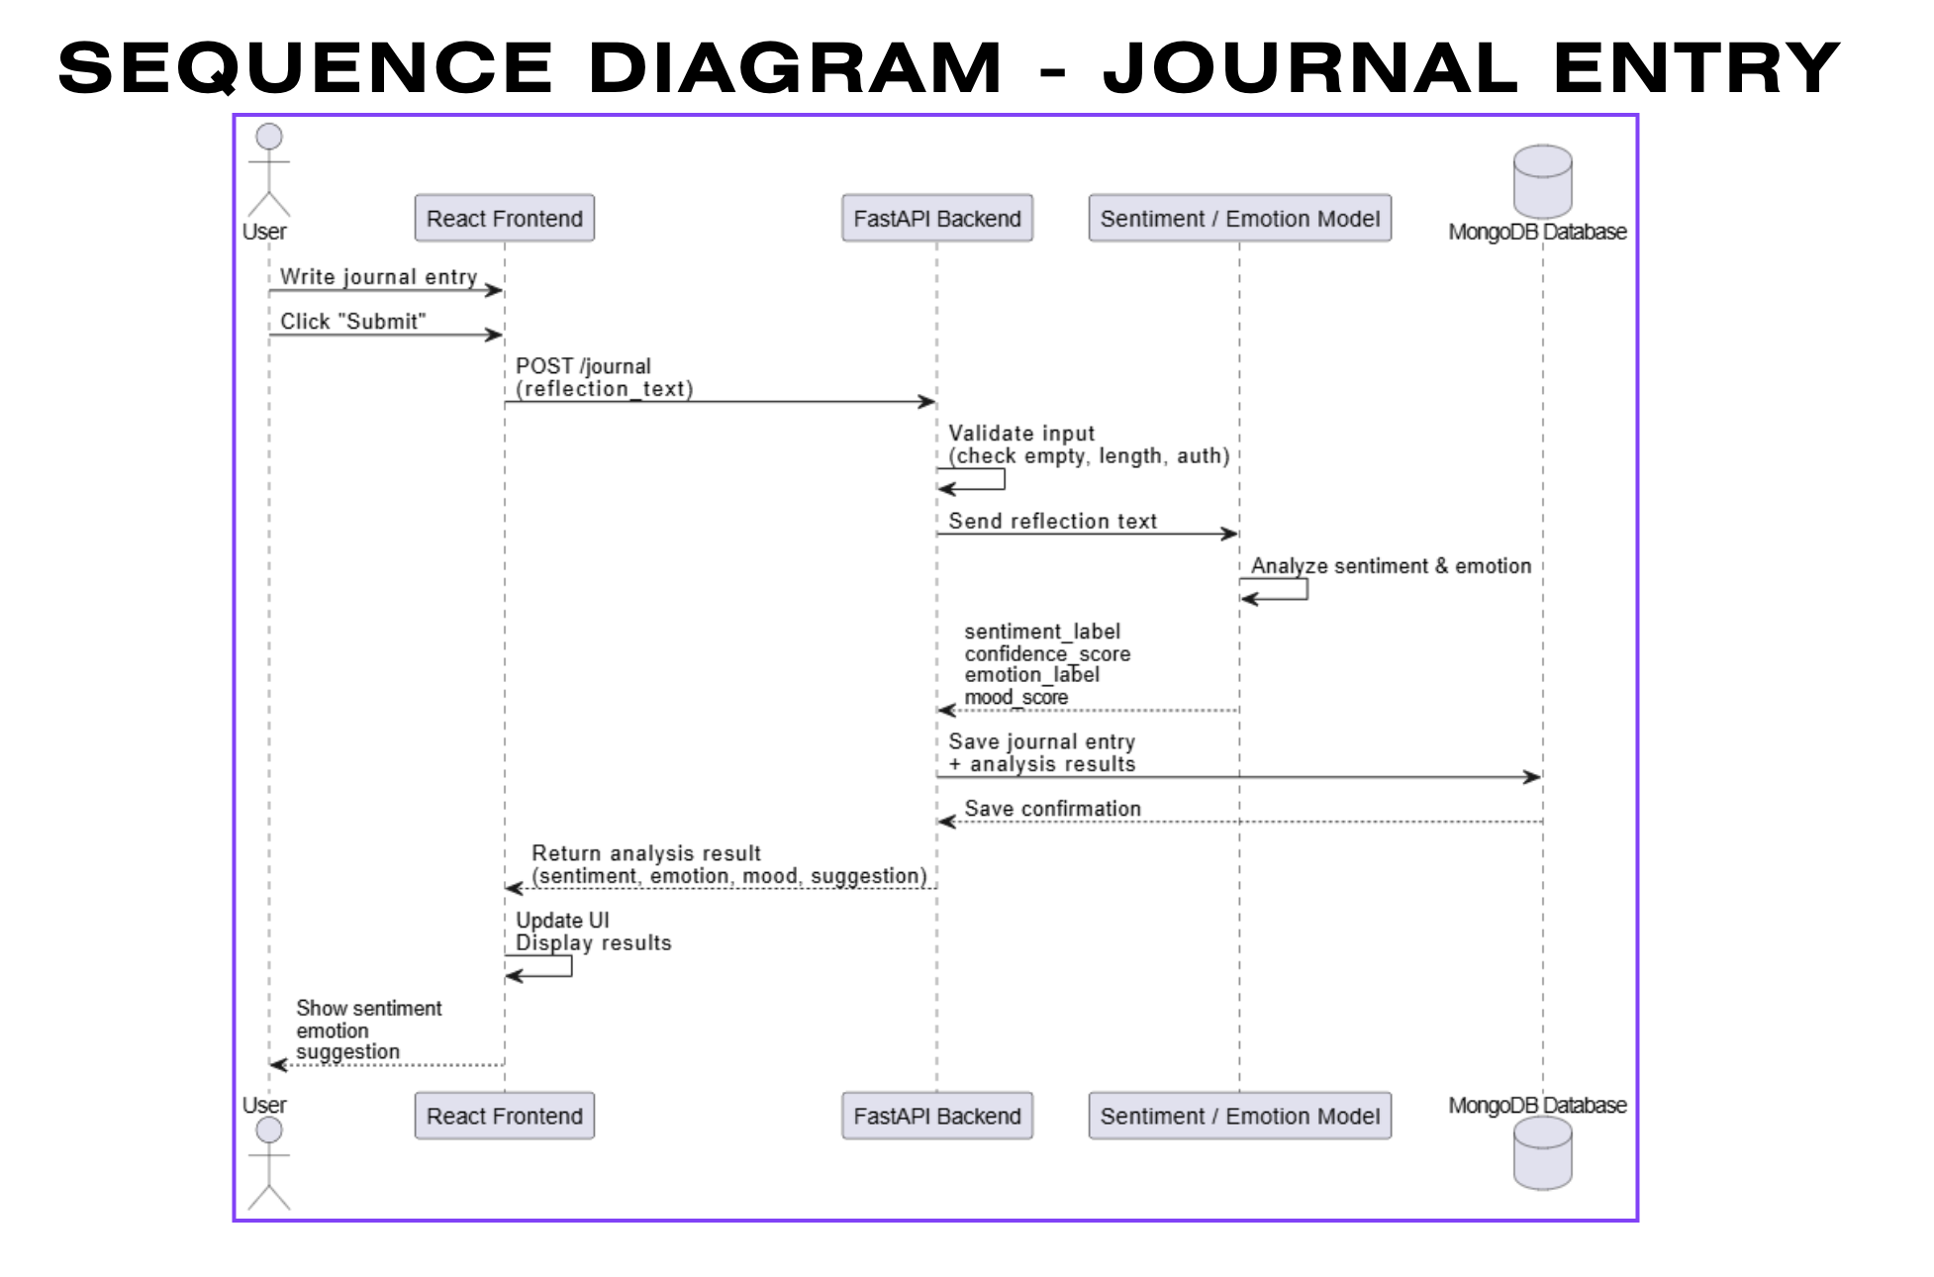
- Sequence Diagram – Journal Entry

Sequence Diagram Dashboard
Figure 5 shows the dashboard workflow. When the user opens the dashboard, the React frontend requests journal history from the FastAPI backend. The FastAPI backend queries MongoDB for entries associated with the current user, formats the returned records into a JSON payload, and sends them back to the frontend. The frontend then generates a mood chart and entry list so that the user can examine mood trends and prior reflections. This workflow is essential to the system's value because emotional pattern recognition depends on reviewing multiple entries over time rather than analyzing one entry in isolation.

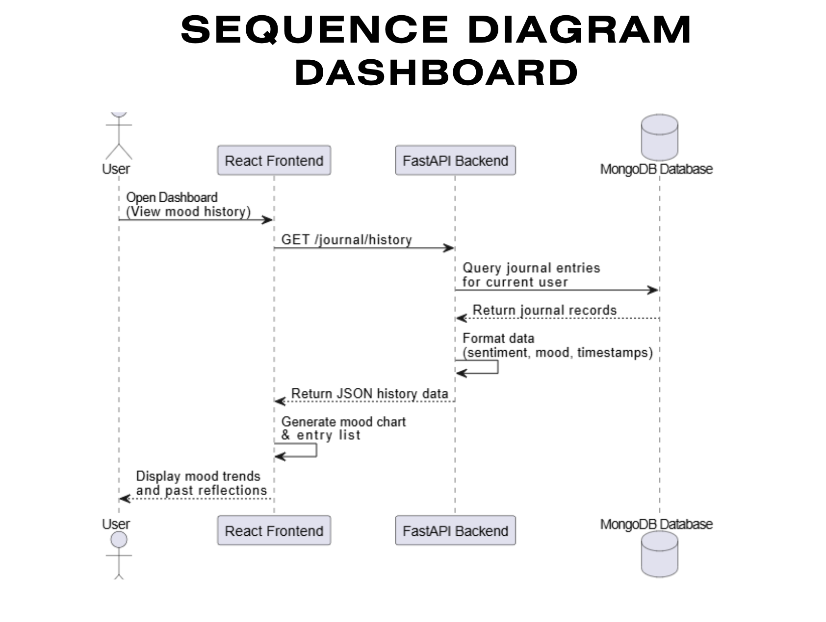
- Sequence Diagram – Dashboard

Sequence Diagram Dashboard
Mind Mirror incorporates a fine-tuned natural language processing model to generate sentiment classifications and continuous mood scores from journal entries. The model is based on the DistilBERT architecture and is implemented using the HuggingFace Transformers framework with a PyTorch backend.
The model utilizes the DistilBERT-base-uncased encoder, which consists of six transformer layers, a hidden size of 768, and 12 attention heads, totaling approximately 66 million parameters. A linear regression head is applied to the encoded representation to predict a numerical mood score on a scale from 1 (very negative) to 5 (very positive).
The model is trained using the GoEmotions dataset, which contains approximately 58,000 labeled text samples. The dataset is divided into 43,410 training samples, 5,426 validation samples, and 5,427 test samples. Each sample includes one or more emotion labels from a set of 27 categories.
To convert multi-label emotion annotations into a single numerical value, a mapping scheme is applied. Positive emotions such as joy, love, gratitude, and optimism are mapped to higher scores (5), while negative emotions such as anger, fear, and sadness are mapped to lower scores (1). Neutral or ambiguous emotions are assigned mid-range values. The final mood score is computed as the average of all mapped values for each sample, allowing transformation from categorical labels to a continuous regression target.
Text inputs are tokenized using the DistilBERT tokenizer with truncation and padding applied to match model input requirements. Non-essential fields are removed, and the processed dataset is used to train the regression model.
Training is conducted using the HuggingFace Trainer API with the following configuration: two training epochs, a batch size of 16, and a learning rate of 2 × 10⁻⁵. The AdamW optimizer is used with weight decay. Model performance is evaluated using Mean Squared Error (MSE) and Root Mean Squared Error (RMSE), which are standard metrics for regression tasks.
During runtime, journal entries are transmitted from the React frontend to the FastAPI backend, which processes inference requests using the trained model. The backend returns both sentiment classifications and mood scores, which are stored in MongoDB and used for visualization within the dashboard.
Although effective, the model has several limitations. The mapping from categorical emotions to numerical mood values may oversimplify complex emotional states. Additionally, the model is trained on Reddit-based data, which may not fully generalize to personal journaling contexts. The regression output is also not strictly bounded, and extreme inputs may produce values outside the intended range.

Results
Mind Mirror was successfully implemented as a functional prototype. In a local development environment, the system supported journal submission, automated sentiment analysis, dashboard-based history retrieval, and data persistence. The frontend remained responsive during common interactions, and the API workflow consistently returned structured results for display. These outcomes indicate that the proposed architecture is feasible for a real-time journaling application in which text analysis and user feedback occur within the same interaction cycle.
The prototype also demonstrated utility at the interface level. Users can write reflections in free-form language, receive immediate sentiment-related feedback, and inspect prior entries through a chart-oriented dashboard. This combination of immediate analysis and longitudinal review helps transform journaling from a passive activity into a guided reflective process. Literature on expressive writing and digital mental health suggests that this structure can support emotional awareness, stress reduction, and sustained engagement when fully evaluated with users [3]-[5].
An important design observation is that sentiment analysis alone is not sufficient unless results are retained and visualized over time. The dashboard workflow therefore serves as a critical complement to the journal-entry pipeline. In the same way, optional suggestion generation adds value by translating analytical output into user-facing guidance. Together, these functions demonstrate how a journaling tool can offer structured support without replacing human judgment or professional care.

Conclusion
Mind Mirror demonstrates how AI-assisted sentiment analysis can be integrated into a journaling application to promote emotional awareness and reflective insight. By combining journal entry analysis with historical visualization, the system provides a more structured alternative to traditional digital diaries. The architecture, data model, and workflow diagrams show that the design can support real-time analysis, durable storage, and trend-based review within a cohesive web application.
The present study has several limitations. Formal user testing was not conducted during this phase, and evaluation was therefore limited to prototype functionality and literature-supported expectations. In addition, the current version has not yet been deployed in a production environment; deployment is planned after the final sprint. Sentiment analysis models may also oversimplify nuanced emotional expression, and future production use would require stronger privacy controls and healthcare-aligned compliance measures for therapist-facing workflows.
Future work will focus on production deployment, empirical testing with students and therapists, improved emotion-detection models, and extension of the therapist-sharing workflow. Additional work may include mobile support, richer annotation features, and stronger privacy controls for real-world clinical or wellness-oriented settings. Overall, the system suggests that AI-powered journaling can serve as a meaningful bridge between personal reflection and structured emotional insight.

Acknowledgment
The authors acknowledge the guidance and support of the Seidenberg School of Computer Science and Information Systems, Pace University, and the project advisors who provided feedback throughout the design and implementation process.

References
The template will number citations consecutively within brackets [1]. The sentence punctuation follows the bracket [2]. Refer simply to the reference number, as in [3]—do not use “Ref. [3]” or “reference [3]” except at the beginning of a sentence: “Reference [3] was the first ...”
Number footnotes separately in superscripts. Place the actual footnote at the bottom of the column in which it was cited. Do not put footnotes in the abstract or reference list. Use letters for table footnotes.
Unless there are six authors or more give all authors’ names; do not use “et al.”. Papers that have not been published, even if they have been submitted for publication, should be cited as “unpublished” [4]. Papers that have been accepted for publication should be cited as “in press” [5]. Capitalize only the first word in a paper title, except for proper nouns and element symbols.
For papers published in translation journals, please give the English citation first, followed by the original foreign-language citation [6].

- C. J. Hutto and E. Gilbert, "VADER: A Parsimonious Rule-Based Model for Sentiment Analysis of Social Media Text," in Proc. International AAAI Conference on Web and Social Media (ICWSM), Ann Arbor, MI, USA, 2014, pp. 216-225.
- M. de Zwaan, J. Saekow, A. E. Mitchell, and A. L. Schlegl, "Web-Based Fully Automated Self-Help With Different Levels of Therapist Support for Individuals With Eating Disorder Symptoms: A Randomized Controlled Trial," Journal of Medical Internet Research, vol. 19, no. 6, 2017, e204.
- J. W. Pennebaker and C. K. Chung, "Expressive Writing: Connections to Physical and Mental Health," in H. S. Friedman, Ed., Oxford Handbook of Health Psychology. Oxford, U.K.: Oxford University Press, 2011, pp. 417-437.
- I. Miralles, C. Granell, C. Diaz-Sanahuja, M. Van Woensel, H. Bretón-López, P. Mira, A. Castilla, and J. M. Casteleyn, "Smartphone Apps for the Treatment of Mental Disorders: Systematic Review," JMIR mHealth and uHealth, vol. 8, no. 4, 2020, e14897.
- J. M. Smyth, "Written Emotional Expression: Effect Sizes, Outcome Types, and Moderating Variables," Journal of Consulting and Clinical Psychology, vol. 66, no. 1, pp. 174-184, 1998.

